Carrying out a related (within-subjects) one-way ANOVA in SPSS.

A psychologist is interested in whether the effects of a homeopathic drug on headaches become more apparent over the course of 5 weeks. Participants symptoms are measured using a questionnaire (The Stirk-Robinson Headache Questionnaire - SRHQ) and scores over a 5 week period are analysed using a one-way ANOVA.

Data is below:

 | Week | Week | Week | Week | Week
 | 1 | 2 | 3 | 4 | 5
Subject
1 | 21 | 22 | 8 | 6 | 6
2 | 20 | 19 | 10 | 4 | 9
3 | 7 | 5 | 5 | 4 | 5
4 | 25 | 30 | 13 | 12 | 4
5 | 30 | 33 | 10 | 8 | 6
6 | 19 | 27 | 8 | 7 | 4
7 | 26 | 16 | 5 | 2 | 5
8 | 13 | 4 | 8 | 1 | 5
9 | 26 | 24 | 14 | 8 | 17

1. Open SPSS and prepare the data sheet for data entry.
Each level of your IV must have a separate column heading. Headings represent the level of your IV and not the name of the IV itself. This will be specified later.

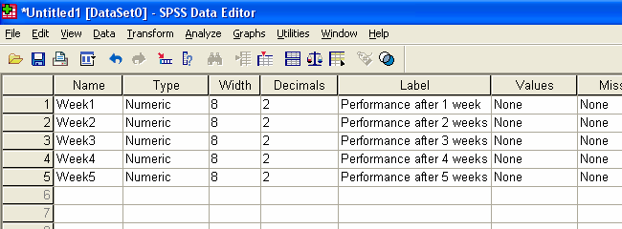

2. Enter data into spreadsheet/data view window

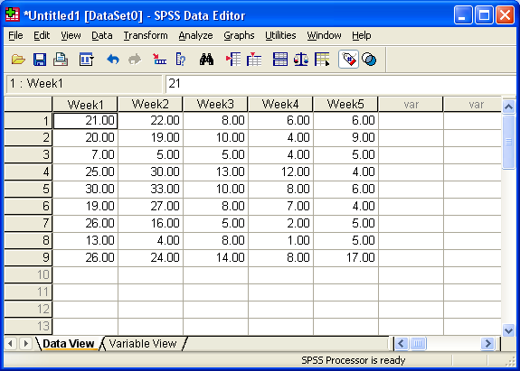

3. Choose Analyze – GLM – Repeated Measures

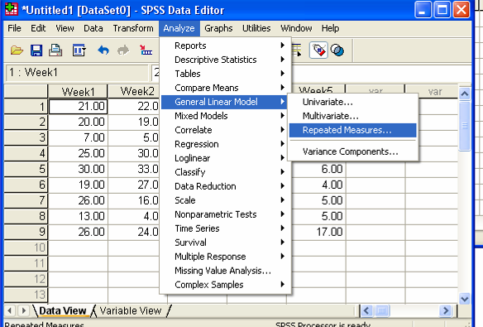

4. Name (Define) the repeated measures IV and ADD, name the DV and ADD:

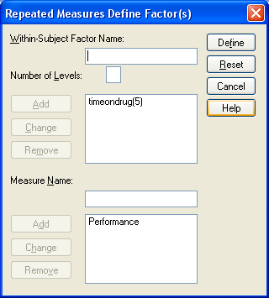
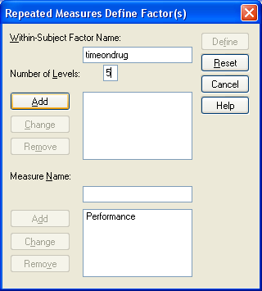

5. Then click Define

6. Bring each variable representing your levels of the IV over into the within-subjects variables box:

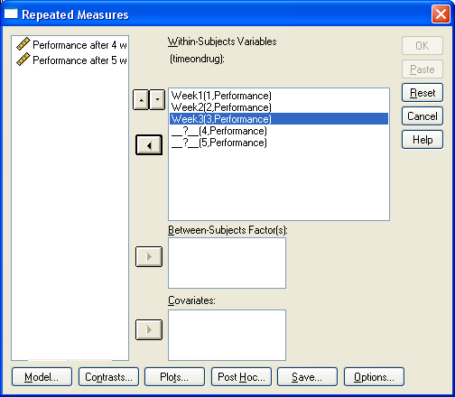

7. Then click OK to output the analysis (You may want to also output means and a graph using the Options and Plots buttons).
8. Examine the output:

Mean scores are seen in the table below (assuming you asked for them using the options button)

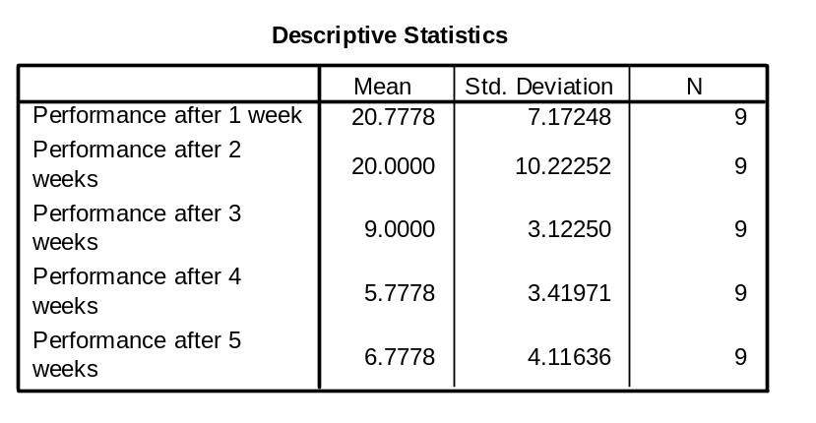
Also as a graph (Plot)
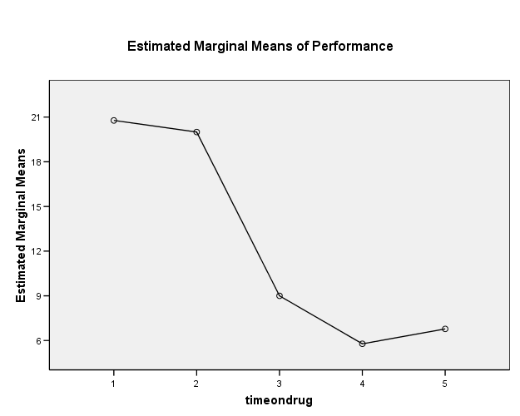
It certainly looks like the means are not all the same, but we must check the table below to be sure:

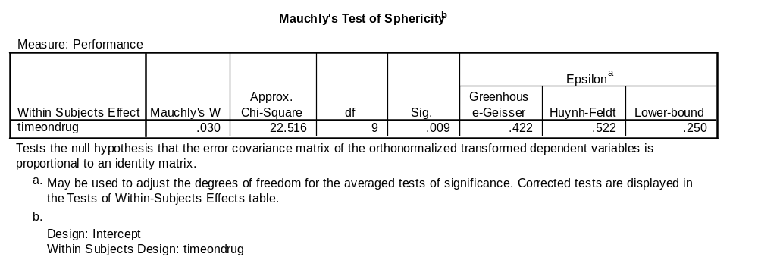

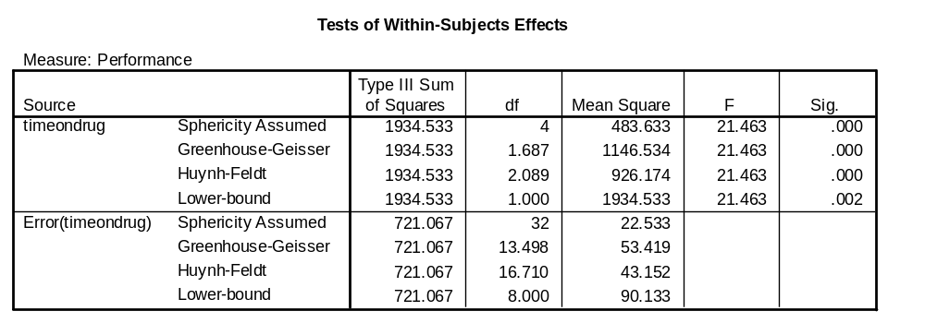

First of all we need to check that the assumption of sphericity is met. Mauchly’s test will tell us this. If the significance of Mauchly’s test is greater than 0.05 (i.e. non-significant) then sphericity is assumed. If sphericity is not assumed then we can use a corrected F value from the tests of within-subjects table (above). When reporting the test of sphericity, we report the chi-square value and the associated p and df.

e.g. “Mauchly’s test indicated that the assumption of sphericity had been violated, χ² (9) = 22.52, p < 0.05, therefore a corrected value (Greenhouse-Geisser correction) of F was used.”

We can now check the appropriate line from the table showing the tests of within-subject effects and report the F value as follows:

“The results show that headache symptoms are affected by the amount of time since the homeopathic treatment began, F (1.69, 13.50) = 21.46; p < 0.05.” Degrees of freedom can be rounded up e.g. F(2, 14) = 21.46; p < 0.05.

These results therefore tell us that there is a significant difference somewhere between the means, but we do not know which means differ from the others. We must therefore carry out what are called post-hoc tests to determine which pairs of means differ from each other. We can do this by following-up with sets of paired-samples t-tests. Because we are carrying out a large number of comparisons, we must control for increased error by using a Bonferroni correction for a significant p value (this is the alpha value divided by the number of paired comparisons).

We could carry out all the related-samples t-tests one by one in SPSS or we can have SPSS do this automatically for us as follows:

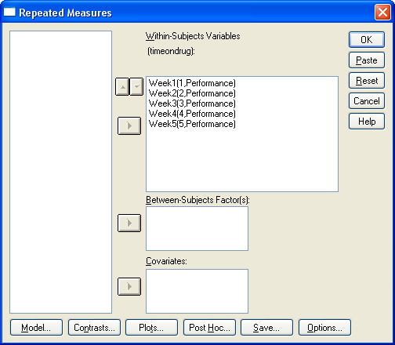

9. Re run the ANOVA but this time click options once you have defined the within-subjects variables.

10. Tick the compare main effects tick-box and choose Bonferroni as an adjustment in the pull-down menu.
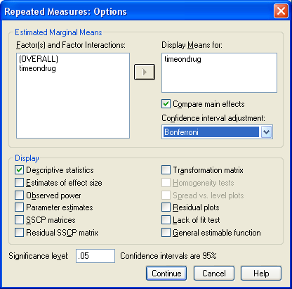

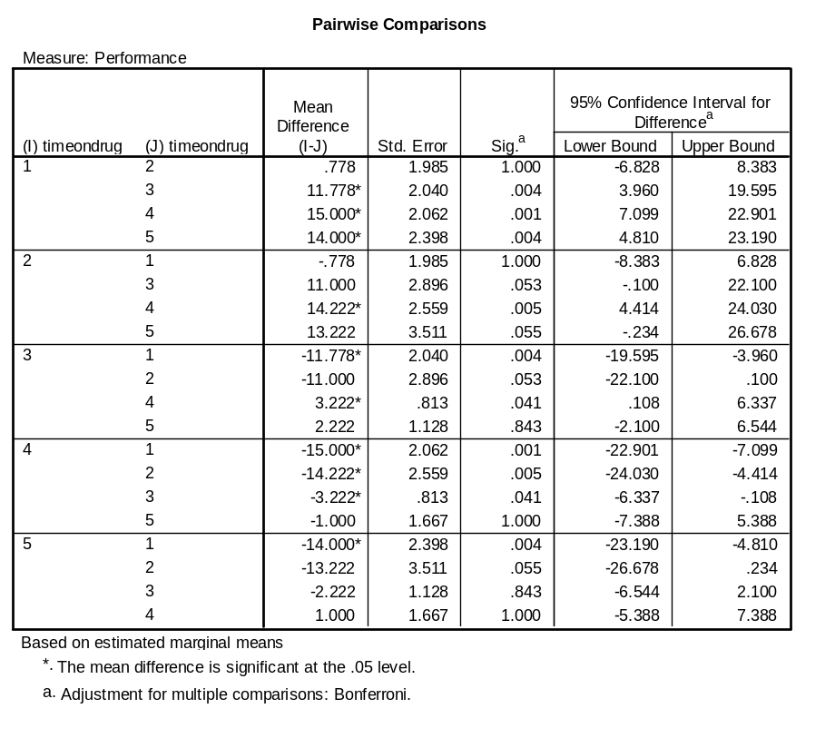
Those pairs of means marked with a * are significantly different at p< 0.05
We can report these findings as follows:

“Paired comparisons were made to examine which pairs of means differed. After 2 weeks subjective report of headaches did not differ from week 1 reports (p > 0.05). However after 3 weeks, reports significantly dropped from week 1 and remained low (p’s < 0.05). By week 4 measures on the SRHQ had reached a plateau and remained low by week 5 (p > 0.05)…….”

